**Project Documentation**

**Data Cleaning**:

* Datatype conversion
* Removing duplicates
* Date type conversion
* Checking for blanks

**Excel Tasks:**

* Creating a pivot table to summarize total sales by store and product category.

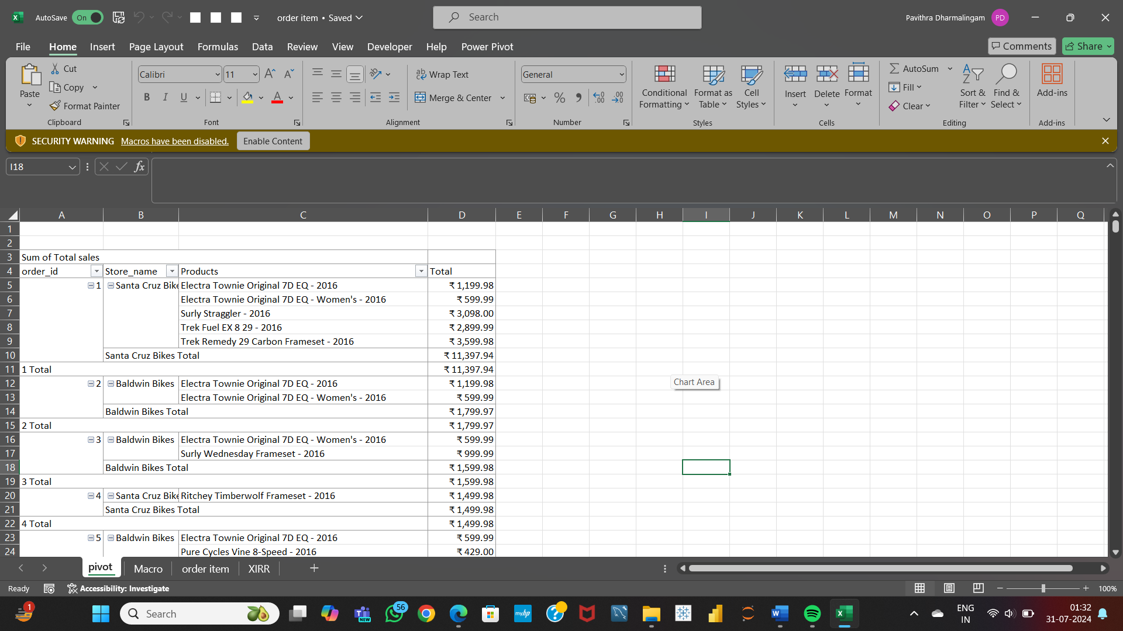

* Performing VLOOKUP to match product names with their respective categories and brands.
* To validate all email addresses in the staffs table are unique and correctly formatted.
* Create a bar chart to visualize the total sales by store.

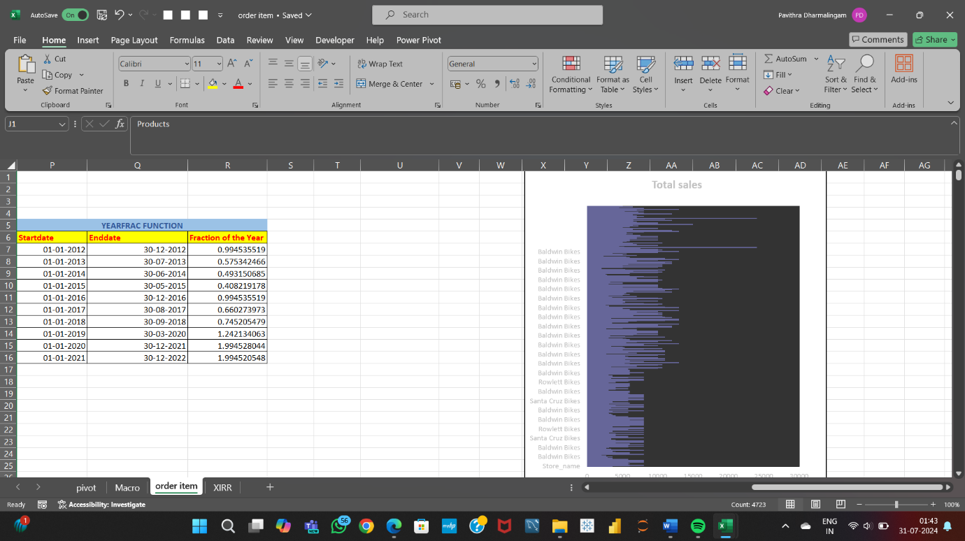

* Performing what-if analysis to see how changes in discount rates affect total sales.

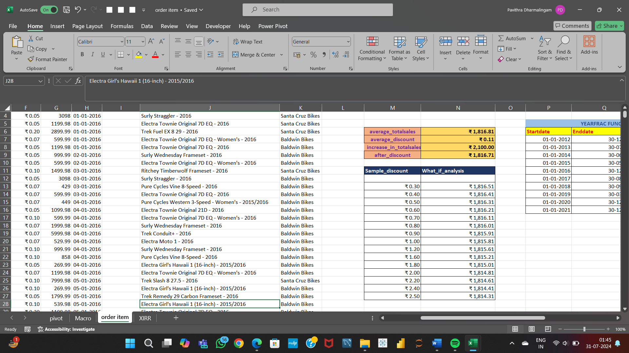

* Automating the process of updating sales reports using macros.

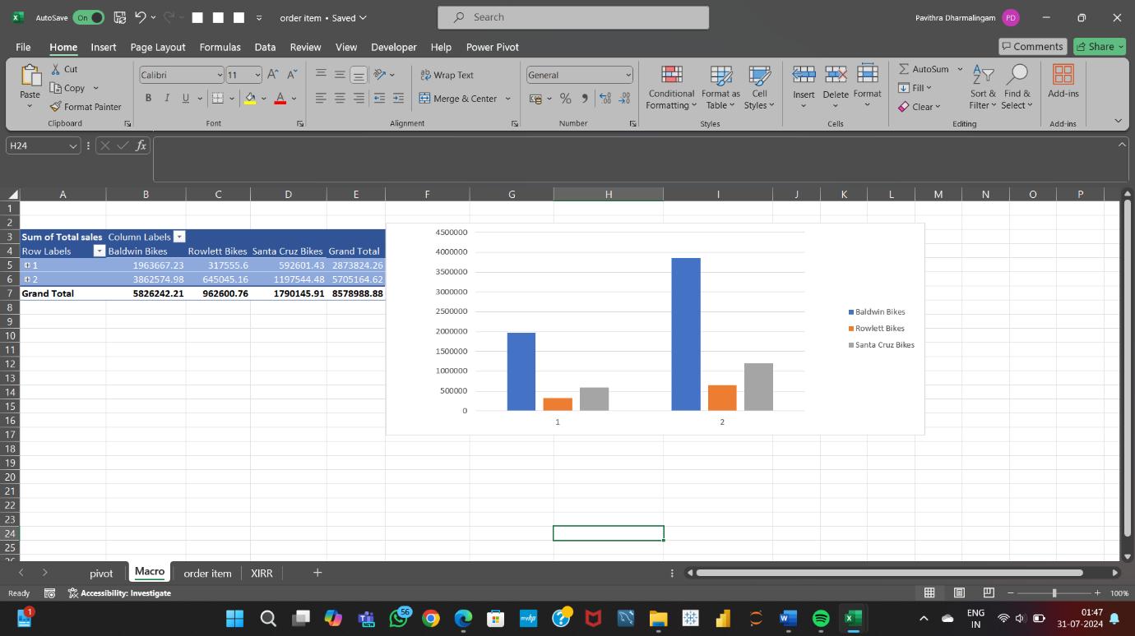

* Using YEARFRAC and XIRR

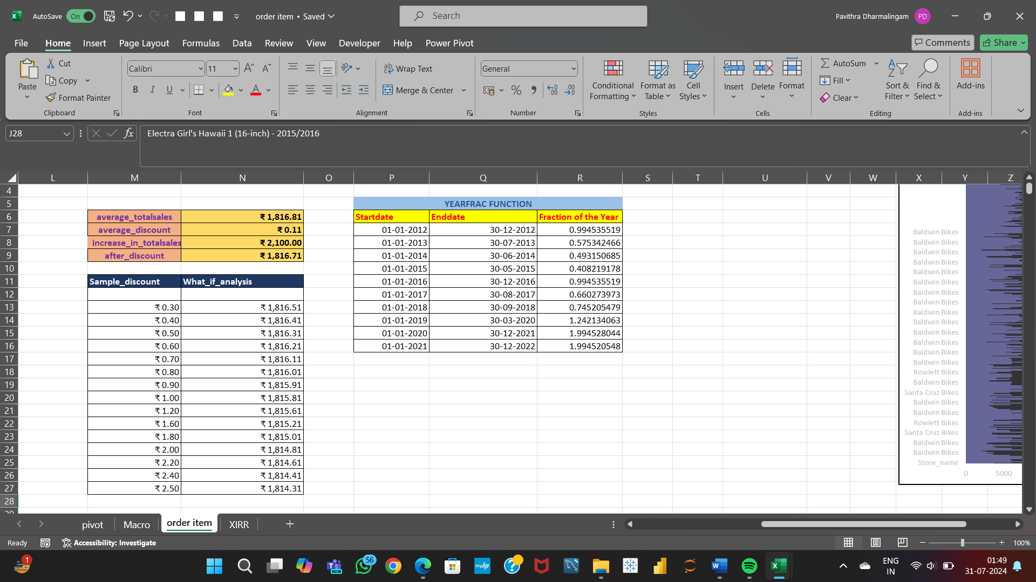

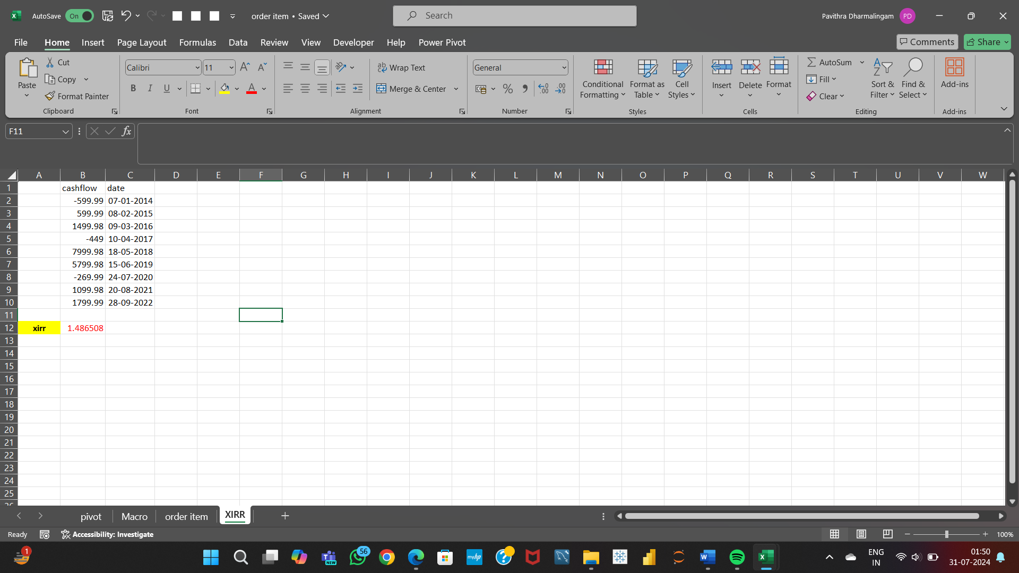

**SQL Tasks:**

* Retrieving all details of customers who have placed orders by joining customers and orders tables.

**select first_name from customers join orders on customers.customer_id = orders.customer_id;**

* Using aggregate functions like SUM and GROUP BY to calculate total sales from the orders and order_items tables.

**select order_id, (round(sum(Total_sales),2)) as total_sale from order_item group by order_id;**

* Writing a subquery to identify products in the products table that do not appear in the order_items table.

**select product_name, product_id from products**

**where not exists (select null from order_item where products.product_id = order_item.product_id);**

* Ranking stores based on their total sales.

**select s.store_name, (round(sum(oi.Total_sales),0)) as sales,**

**rank() over (order by sum(oi.Total_sales) desc) as rankno**

**from stores as s**

**left join orders as o on s.store_id = o.store_id**

**left join order_item as oi on o.order_id = oi.order_id group by s.store_name;**

* Calculating the number of days each order took to ship

**select order_id,**

**datediff (new_sdate,new_date) as no_of_days**

**from orders;**

* Categorize orders based on their status using case statement**.**

**select order_id,**

**(case**

**when order_status >= 0 and order_status <= 1 then 'First Category'**

**when order_status >= 1 and order_status <= 2 then 'Second Category'**

**when order_status >= 2 and order_status <= 3 then 'Third Category'**

**when order_status >= 4 then 'Fourth Category'**

**end) as category**

**from orders;**

* Retrieve all orders along with the product names and the store names using complex joins

**select o.order_date,s.store_name, p.product_name , round(oi.Total_sales,0) as Sales**

**from orders as o**

**left join order_item as oi on o.order_id = oi.order_id**

**left join products as p on oi.product_id = p.product_id**

**left join stores as s on o.store_id = s.store_id ;**

* Create a temporary table to store intermediate sales calculations.

**create temporary table temp_orders (**

**order_id int, customer_id int,**

**order_date date, shipped_date date,**

**store_is int,staff_id int, customer_name VARCHAR(50), sales double);**

**PowerBI:**

* Create a bar chart to show total sales by product category.

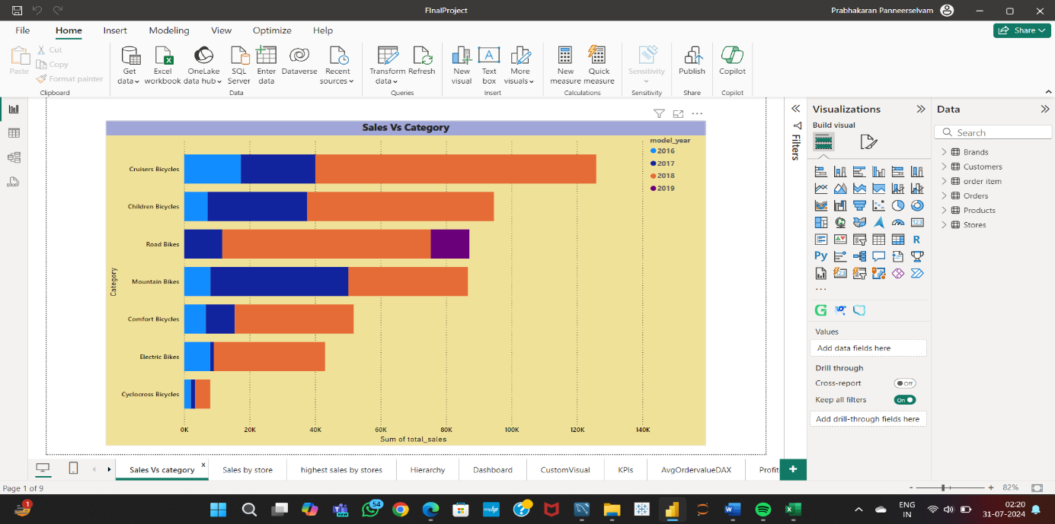

* Adding slicers to filter sales data by store and date range.

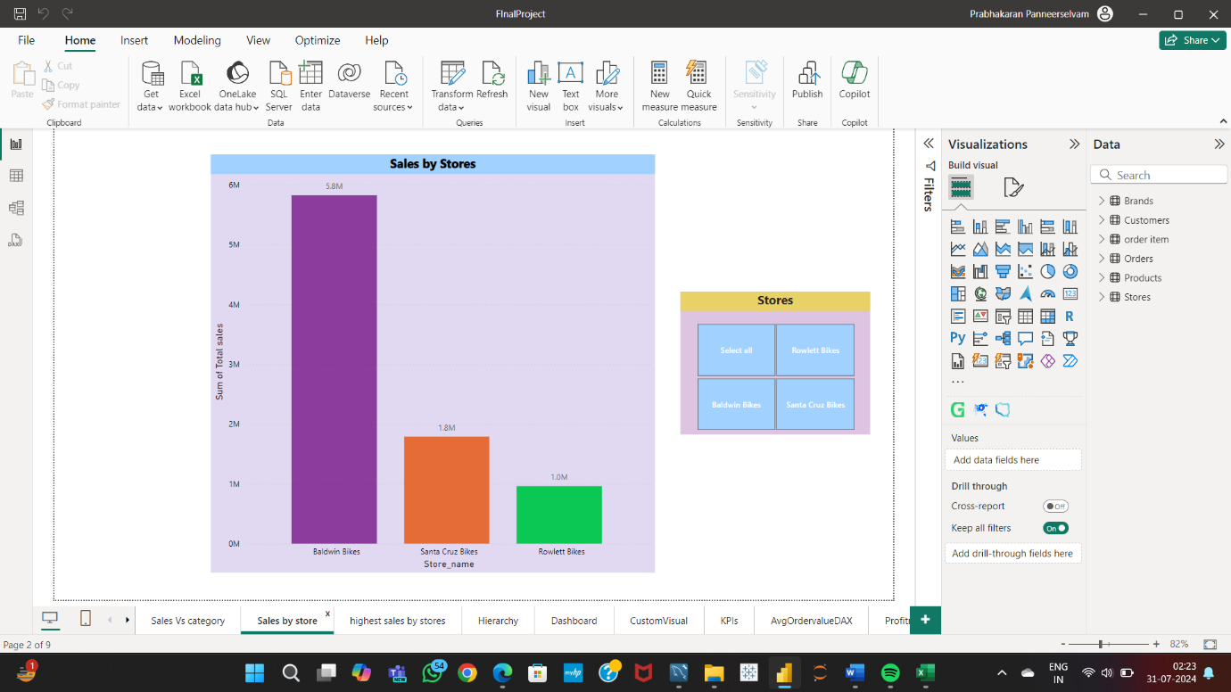

* Creating a calculated column to show the profit margin for each order item using DAX

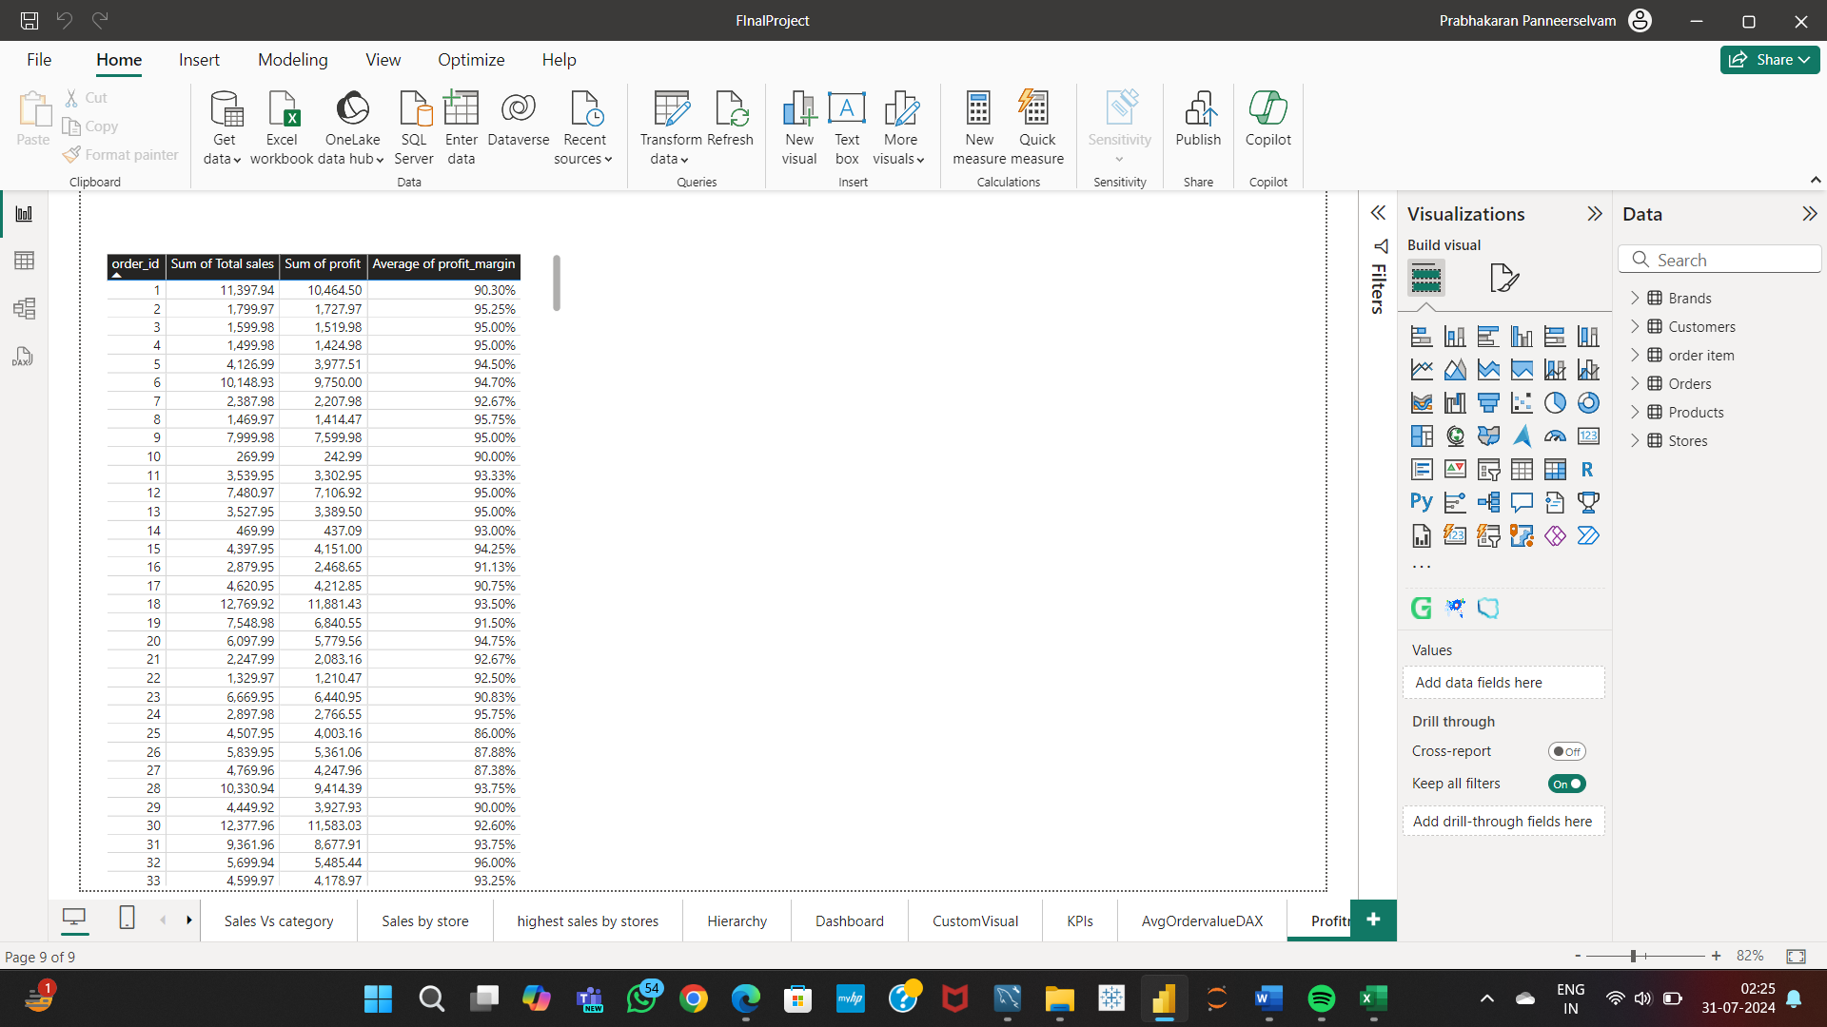

* Creating a measure to calculate the average order value using DAX

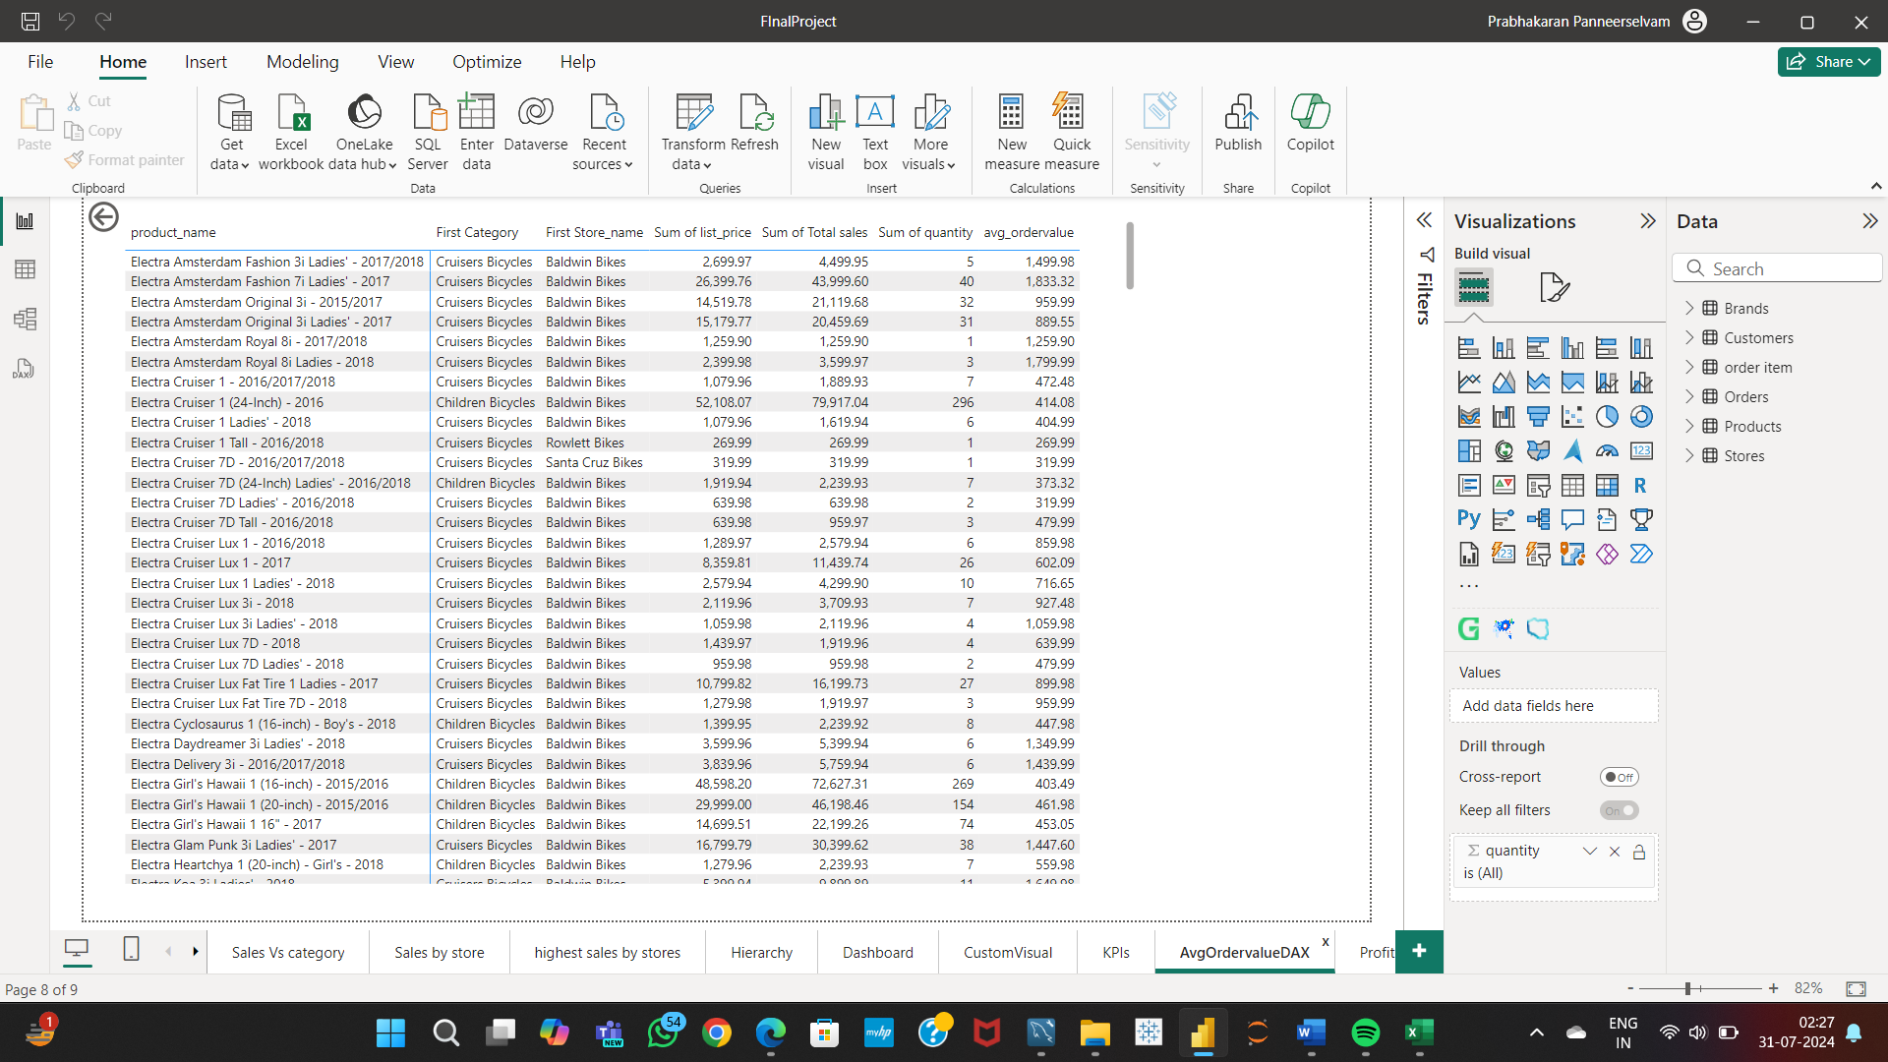

* Appling conditional formatting to highlight top-performing stores.

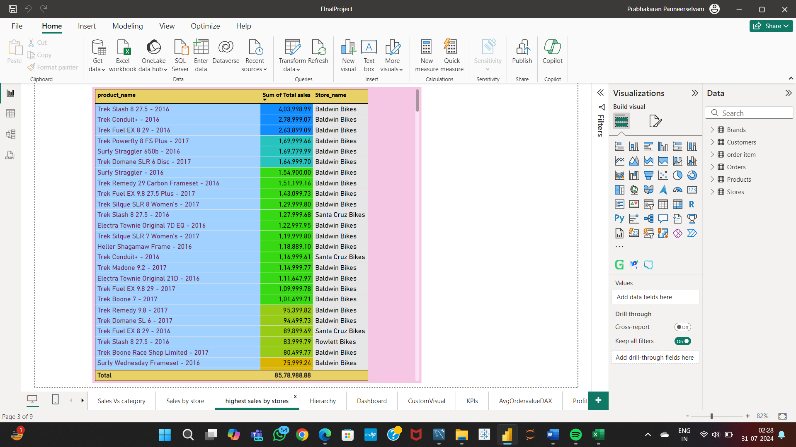

* Creating a hierarchy for drill-down analysis of sales data by year, month, and day.

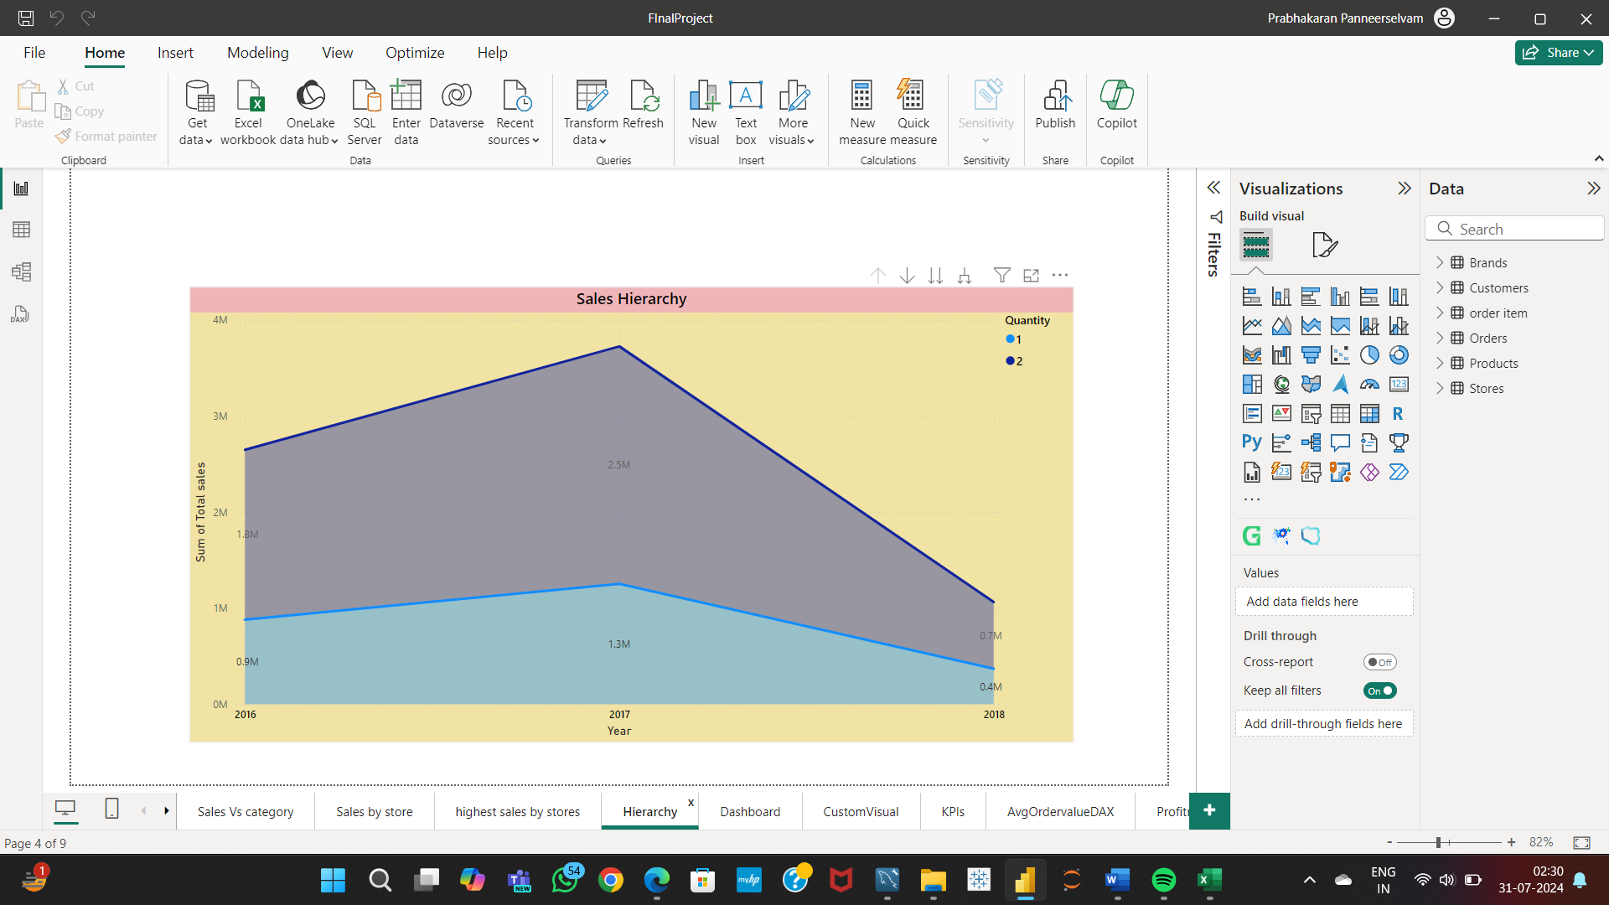

**Dashboards:**

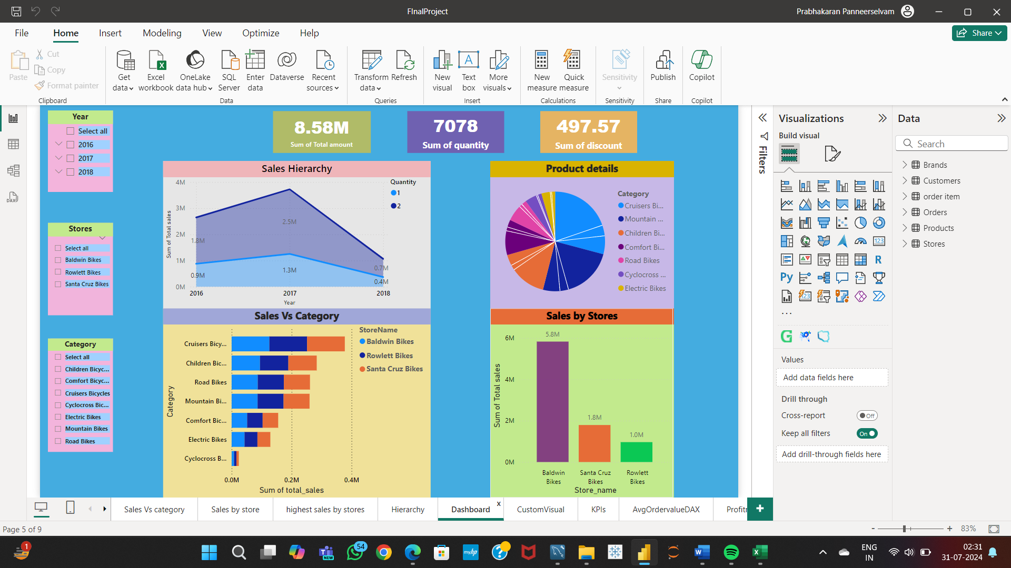

**Custom Visuals:**

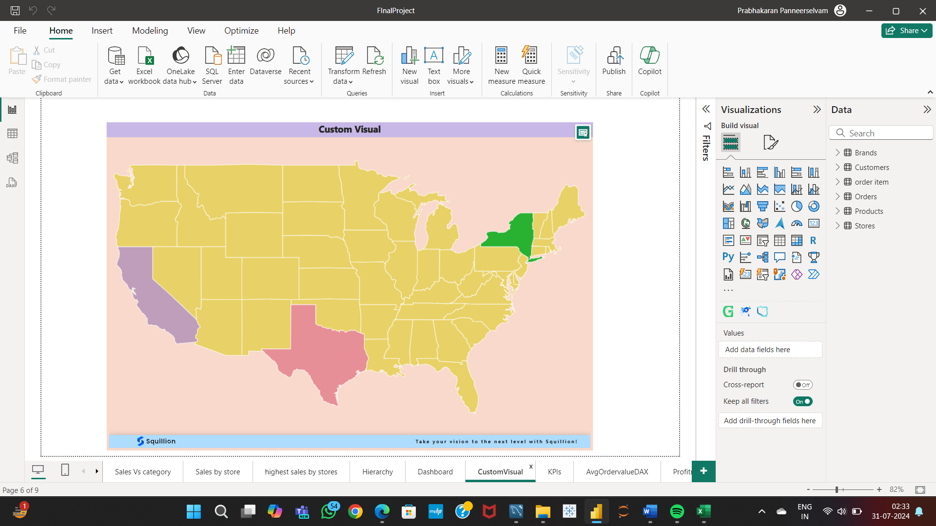

* Create KPIs to track sales targets versus actual sales.

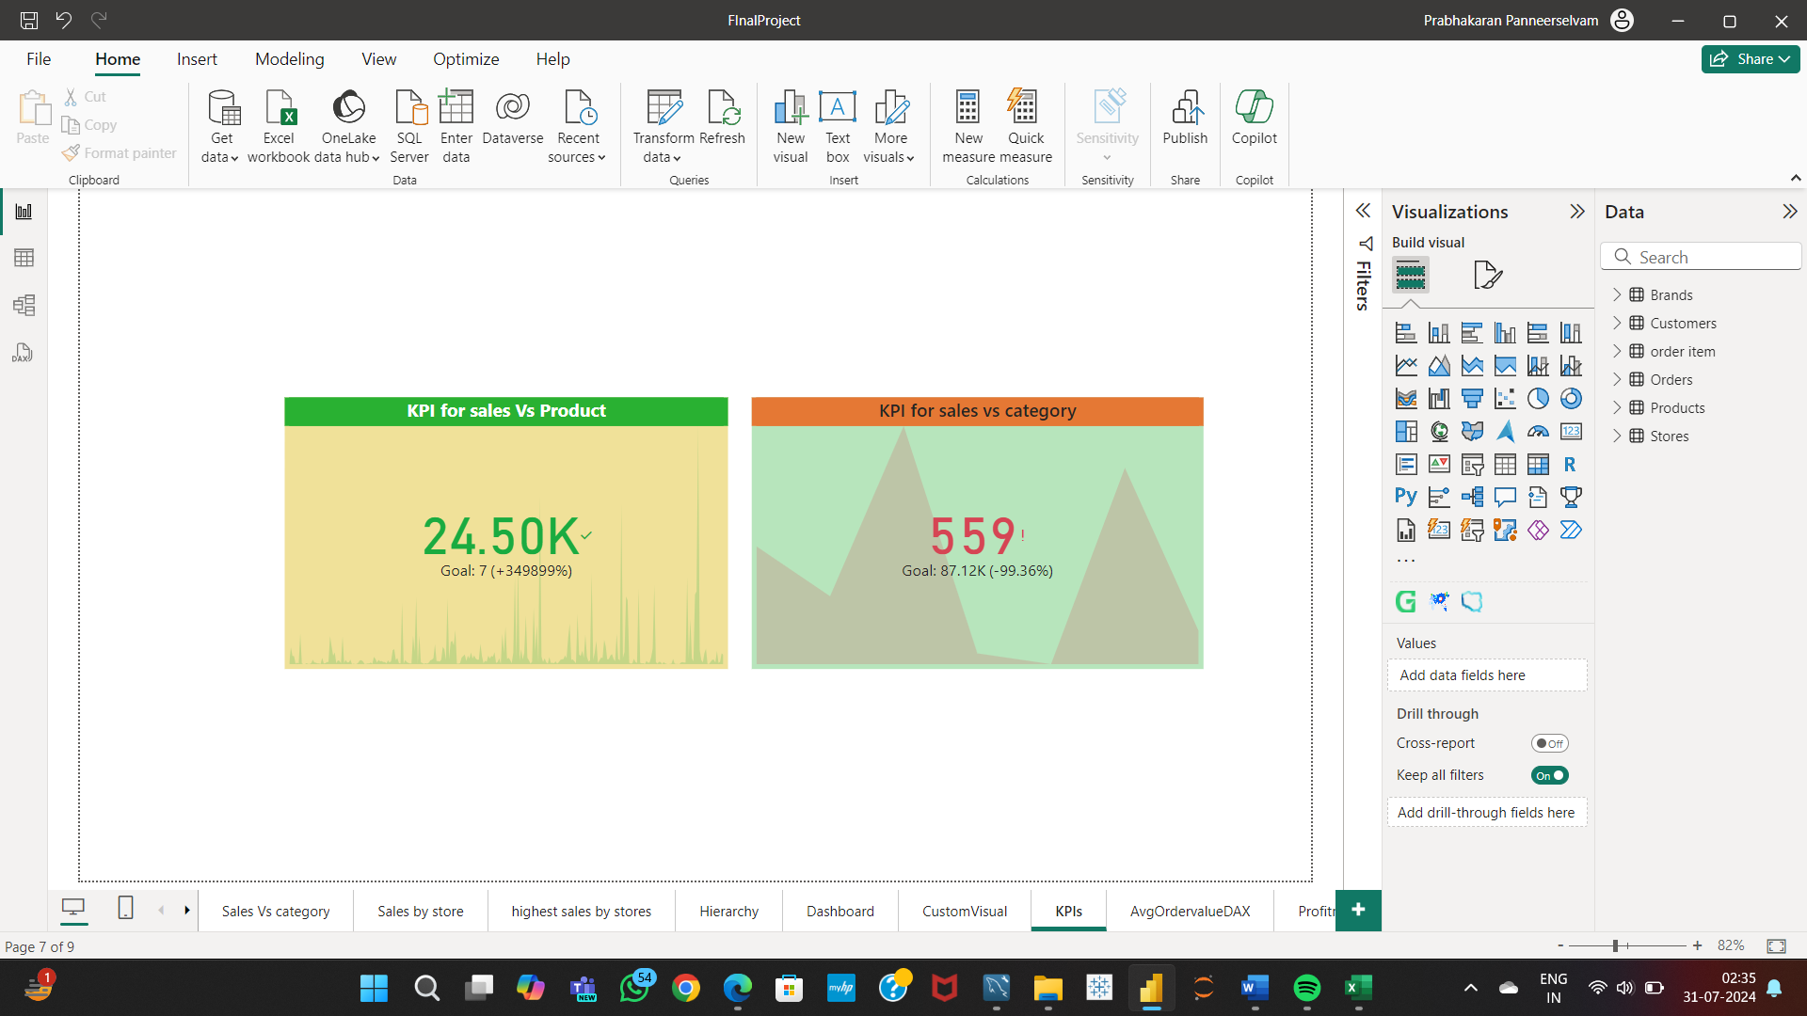

**Excel to PowerBI:**

The dashboard includes all the task given.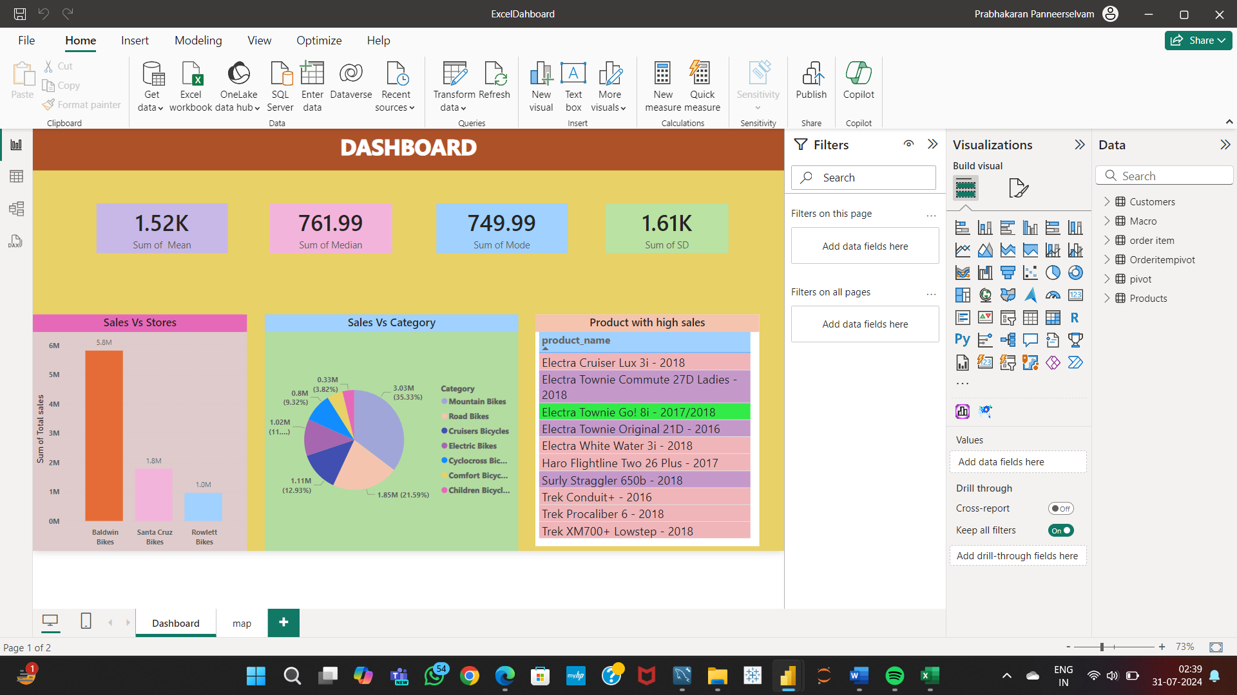

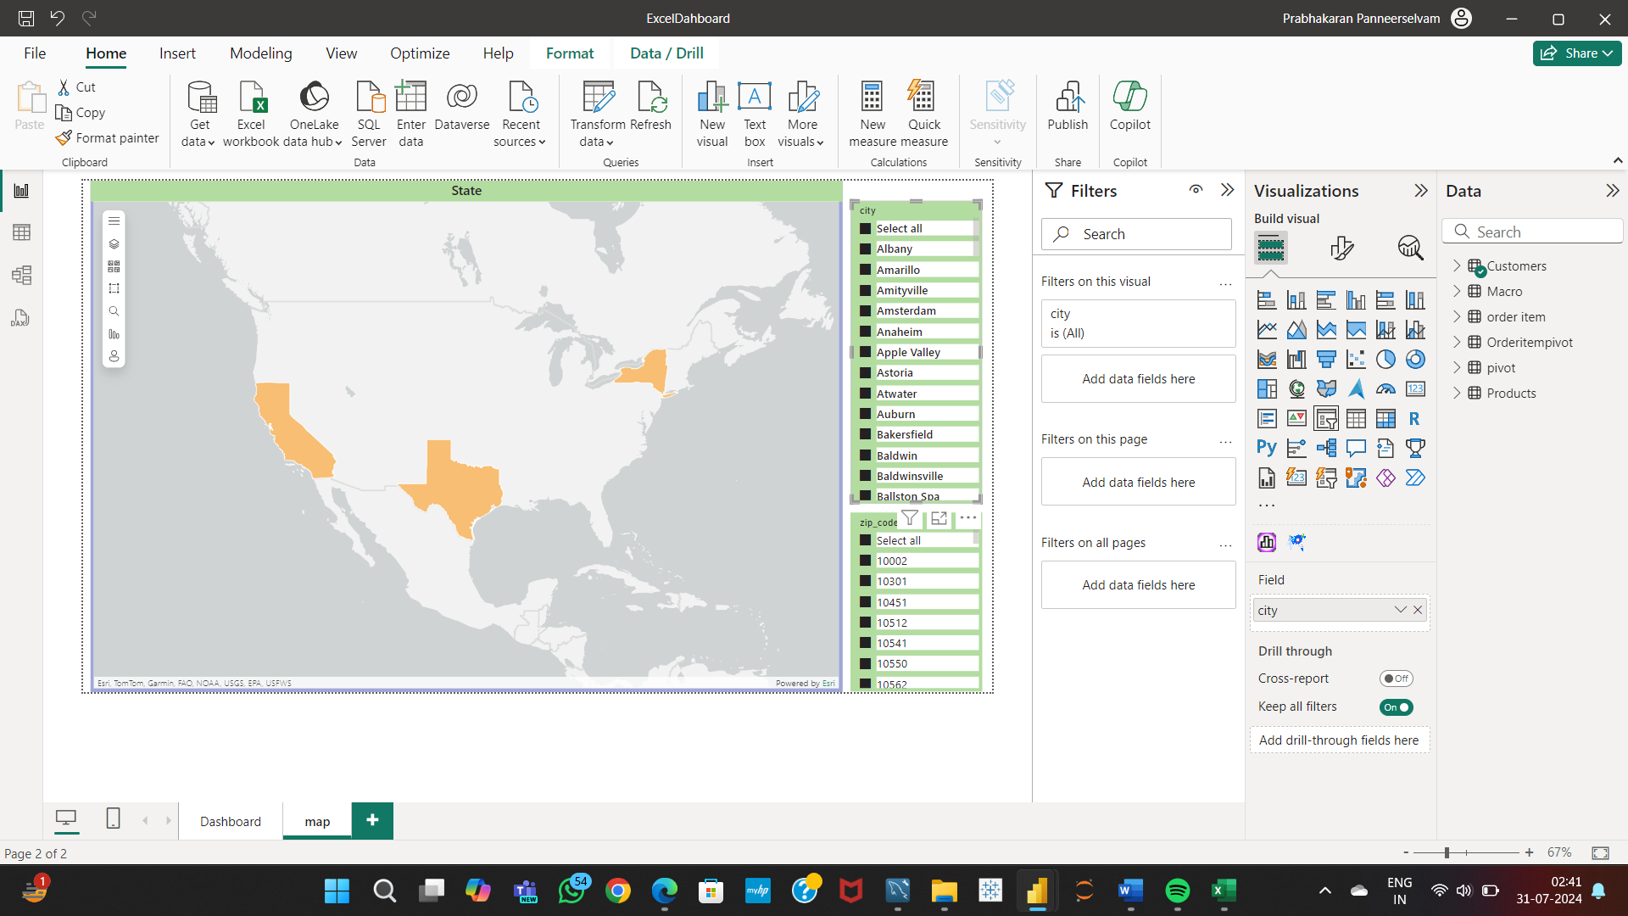

**SQL to PowerBI:**

* Importing the result of the query retrieving details of customers who have placed orders into Power BI.

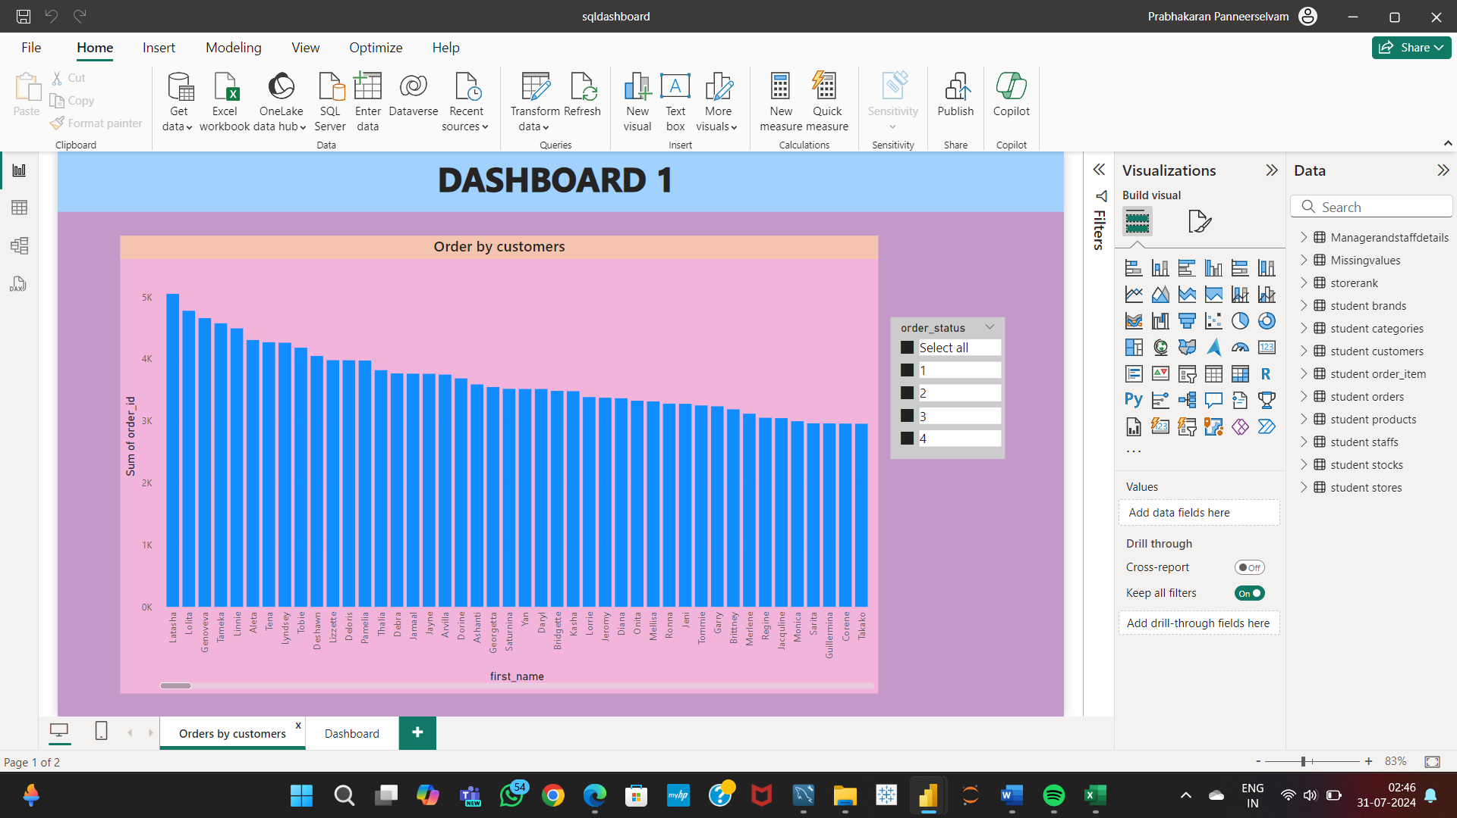

* The dashboard contains all the tasks given.



